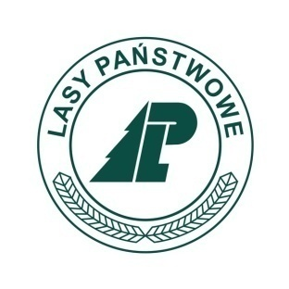
International Conference
"Decade of Polish Tree Beekeeping"
Spała, 19-20.06.2017

REGISTRATION FORM
Participant:
Name and surname:...............................................................................................................................................
Job position, scientific title:..................................................................................................................................
Institution:..............................................................................................................................................................
Phone: ...................................................E-mail:....................................................................................................
Address:.................................................................................................................................................................

Invoice information:
Institution:..............................................................................................................................................................
Address:.................................................................................................................................................................
...............................................................................................................................................................................
Account number (in case of necessity of returning money):....................................................................................

Reservation-accommodation (if you're interested mark X)
Accommodation price | 18/19.06.2017 | 19/20.06.2017
142,36 PLN*

Reservation-meals (if you're interested mark X)
18.06.2017 | 19.06.2017 |  |  | 20.06.2017
Dinner (21,64 PLN*) | Breakfast (18,22 PLN*) | Lunch (28,47 PLN*) | Dinner party (79,95 PLN*) | Breakfast (18,22 PLN*) | Lunch (28,47 PLN*)

Registration fee:
1 participant - 360,00 PLN* Total to be paid(PLN)-.......................................
*gross prices

Contact in English: Sylwia Pazura, e-mail: sylwia.pazura@vp.pl, +48 668 438 492.
YES
NO

Participation in outdoor activities (20.06.2017):

The condition of participation in conference is making a payment (accommodation, meals, registration fee) to account number: 45 1600 1462 1016 7912 4000 0002 - no later than 01.06.2017 with "conference" note.
Remarks:....................................................................................................................................................................
Registration is treated as an evidence of transacted agreement.
Resignation from participation in conference is possible only in written form (e-mail or fax), no later than to 01.06.2017.
In case of resignation before 01.06.2017 the payment will be return. In case of resignation after 01.06.2017 the payment won't be return.
I accept conditions of participation in conference and I commit to pay all costs of participation (registration fee, accommodation and meals).
.............................................
Signature

Registration form is needed to be send to 01.06.2017 by e-mail: ewa.korzeniewska@lodz.lasy.gov.pl, by fax: +48 44 725 70 52 or by the post: Nadleśnictwo Spała, ul. A.Gabrysiewicza 2, 97-215 Inowłódz.
After reciving registration form we are sending back the confitmation. If you won't recive confirmation after three days from sending your registration form please contact us by email.
Organizers reserve the rights to countermand the conference in case of too small number of participants - all payments will be return then.

